1ST PAGE HOME
“About Us”
For us, oil is not just a business — it is a legacy that has grown with our family for more than three generations. Our journey began in the early 1950s, when our grandfather, Mr. Ganapathi Chettiyar, travelled from village to village, carefully selecting the finest sesame seeds. Guided by deep knowledge, integrity, and a commitment to quality, he supplied premium sesame seeds to oil mills for over 35 years. His dedication laid the foundation for our family’s identity and values.
In 1984, inspired by his experience and vision, our family established its first oil mill. With a strong understanding of seed quality and an unwavering commitment to authenticity, the business earned a respected name in the market. After the family’s division, my father, Mr. G. Gopalsamy, carried this tradition forward by founding Sree Rajaganapathy Oil Mill in 2014. With over 42 years of expertise in oil production, he strengthened the brand with a focus on purity, consistency, and customer trust.
Today, we stand by our core principles of:
• Uncompromising Quality
• Fair and Transparent Pricing
• Customer-centric Service
Over the years, we have expanded from gingelly oil to producing groundnut oil and coconut oil, all made using carefully selected raw materials and hygienic processing methods. When we look at our journey, we see more than a business — we see our grandfather’s footsteps, our father’s dedication, and a family tradition built on trust, purity, and quality. It is a legacy we are proud to uphold, and a promise we carry forward into the future.

MISSION STATEMENT
Our mission is to manufacture premium edible oils through advanced cleaning, traditional extraction, and natural filtration methods—without chemicals or refining—while maintaining transparency, customer satisfaction, and consistent quality in every batch.
2ND PAGE

🌟 WHY CHOOSE US

1. Clean & Pure Raw Materials
We use advanced seed-cleaning machines to remove sand, stones, dust, husk, and impurities.
Only clean and high-quality sesame seeds go into production.

2. Traditional Rotary Chekku Extraction
Our gingelly oil is made using rotary chekku, which:
- Generates low heat
- Retains natural aroma & nutrients
- Gives traditional taste
- Is cleaner & faster than wooden chekku

3. Natural Filtration – No Chemicals
After extraction:
- Oil settles naturally in large tanks
- Dust settles at the bottom
- Oil is pressure-filtered through filter cloth
- No refining • No bleaching • No chemicals
100% natural & pure oil.

📊 Chekku Oil vs Expeller Oil (Short Table)
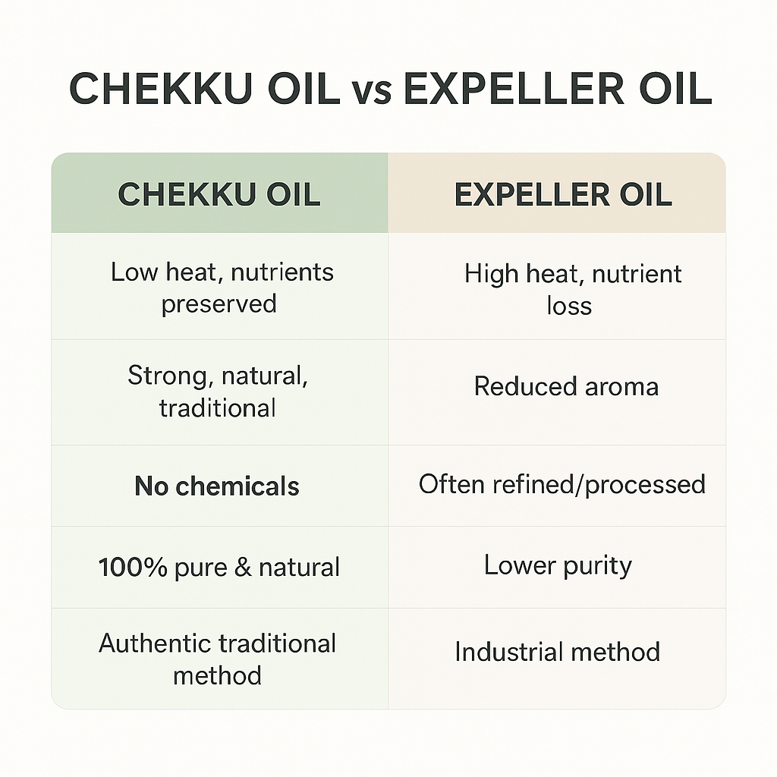

3RD PAGE PRODUCTS
SUB CATEGORY
- SESAME OIL
- GROUND NUTOIL
- COCONUT OIL

4TH PAGE OUR SERVICES

⭐ Local Market Trading & Bulk Supply
We supply high-quality gingelly, groundnut, and coconut oil to retailers, wholesalers, supermarkets, restaurants, sweet and snack manufacturers, bakeries, and catering units.
For bulk buyers, we offer 5L / 10L / 15L cans, 15kg tins, and 200L barrels, ensuring consistent quality, timely delivery, and reliable long-term supply for all business requirements.

⭐ Export Services
(Kept exactly as you approved)
We export our oils to international markets with:
- Strict quality selection
- Hygienic handling and packing
- Export-grade container drums
- Support for documentation & logistics
- Regular supply for long-term clients
Our oils maintain the traditional flavour and purity that global customers expect.

⭐ Private Labelling, OEM & Why Partner With Us (Combined)
We offer full private labelling and contract manufacturing (OEM) for businesses looking to launch or expand their own brand.
Whether you’re a retailer, distributor, exporter, or online seller, we produce and pack oil under your brand name, maintaining complete confidentiality.

What You Get
- Your brand label on bottles, pouches, tins, or cans
- Support with design, artwork, and nutrition details
- Proper batch coding, MRP, and FSSAI guidelines
- Reliable production and consistent quality
- Fast delivery for both local and export clients

Why Partner With Us
- 3 generations of oil expertise
- Trusted in both local and export markets
- Traditional extraction with modern hygiene
- Pure oils with no chemicals or refining
- Honest pricing with dependable supply
- Strong business support for brand growth
We take care of production — you grow your brand with confidence
5TH PAGE

📞 CONTACT US
We are always ready to assist you with product inquiries, bulk orders, export requirements, and private labelling services.

📍 Address
Sree Raajaganapathy Oil Mill
TC Main Road West,
Seerangarayagounden Valasu Road,
Vellakoil, Tirupur District – 638111
Tamil Nadu, India

📱 Phone / WhatsApp
+91 ———— (Add Your Number)
(Available 9:00 AM – 8:00 PM)

📧 Email
sreeraajaganapathyoilmill@gmail.com
(For orders, exports & business enquiries)

🌐 Website
www.sreeraajaganapathyoilmill.com

🕒 Business Hours
Monday – Saturday: 9:00 AM to 8:00 PM
Sunday: Holiday

📩 Enquiry Form
Name
Mobile Number
Email
Product / Requirement
Message Box
Submit Button

📌 Google Map Integration
Embed location map for easy navigation:
“Sree Raajaganapathy Oil Mill, Vellakoil”

